A PROJECT REPORT
ON

Online Gas Booking

SUBMITTED TO THE MSBTE, MUMBAI
IN THE PARTIAL FULFILLMENT OF THE REQUIREMENTS
FOR THE AWARD
OF

DIPLOMA IN COMPUTER TECHNOLOGY
By
Mr.Jadhav Sourabh Ram Enrollment No:-1600950111
Mr.Yelur Akshay Chandrakant Enrollment No:-1500950115
Mr.Botre Mayur Ramesh Enrollment No:-1600950082
Mr.Pandhare Prajwal Bharat Enrollment No:-1700950281

Under the Guidance of
Ms. Jinde S.M.

Department of Computer Technology

Solapur Education Society's Polytechnic, Solapur.
2018 - 2019


CERTIFICATE

This is to certify that the project report entitled
Online Gas Booking
Submitted by:
Mr.Jadhav Sourabh Ram Exam Seat No-211109
Mr.Botre Mayur Ramesh Exam Seat No-211094
Mr.Yelur Akshay Chandrakant Exam Seat No-211086
Mr.Pandhare Prajwal Bharat Exam Seat No-211131
Mr.Jadhav Chaitanya Mahendra Exam Seat No-211089
is a bonafide work carried out by them under the guidance of Ms. Jinde S.M. and it is approved for the partial fulfillment of the requirement of MSBTE, MUMBAI for the award of the Diploma in Information Technology.
This project work has not been earlier submitted to any other Institute or University for the award of any degree or diploma.

Ms. Jinde S.M.
(Project guide)

( ) M.C.Patil Dr. S.B.Joshi
External examiner Head Principal
Department Of Computer Technology S.E.S. Polytechnic,Solapur

Place: Solapur.
Date: 20/03/2019

ACKNOWLEDGEMENT
It gives us a great pleasure to present the project report entitled Online Gas Booking
This project has given us a great learning experience in understanding the various aspects of the Web Site Development. So we would like to acknowledge all the minds and hands that contributed in giving this project a proper shape.

We are grateful to our Hon. Ms.Jinde S.M. our Project Guide for hers encouragement and guidance & keen interest throughout project. We are also thankful to our Head Of Department Mr.M.C.Patil and our Principal Dr. S.B.Joshi for their moral support.

We are thankful to all the staff and non-teaching members of Computer Technology Department for their co-operation during the project work. We are very grateful to those who in the form of books had conveyed guidance in this project work.

INDEX
TOPIC Page No
1 .Abstract………………………………………………………………......….03
2 .Project objective………………………………………………………….…04
2.1 Scope of project…………………………………….……….05
2.1.1 Advantages………………………………………………..06
2.1.2 Goals………………...…………………………….……...06
3 .Information gathering………………..……………………………...…..…06
3.1 Problem Definition…..……………………………………..06
3.1.1 Weakness of Current System….………………………….06
3.1.2 Requirements of the new System…………………………06
3.2 The Literature Review………………………………………07
3.2.1 Technology Used:PHP………….………………………...07
3.2.2Feature of PHP Technology……………………………….07
4 .Software Requirement Analysis ……………………………..……………08
4.1 Design Constraints and Dependencies: ……………………08
4.2 Hardware & Software Requirement: ………………………08
4.2.1 Software Requirement: ………………………………….08
4.2.2 Hardware Requirement: …………………………………08
4.3 User Summary: ……………………………………………08
5 .Risk Management…………………………………………………………09
5.1 Risk Projection: …………………………………………...09
5.2 Risk Identification: ………………………………..……...09
5.3 Risk Monitoring & Mitigation: …………………………...10
6. Project Management: …………………………………………………….11
6.1 Project Plan: ………………………………………………11
6.2 Resources …………………………………………………11
7 .Project Goals……………………………………………………………...12
8. Diagrams……………………………………………………………………13
8.1 Use Case Diagram ………………………………………...13
8.2 Class Diagram …………………………………………….14
8.3 System Activity Diagram …………………………………15
8.4 Data Flow Diagram ……………………………………….16
8.4.1 Level 0 ………………………………………………….16
8.4.2 Level1 …………………………………………………..16
8.5 Control Flow Diagram…………………………………….17
8.6 Sequence Diagram………………………………………...18
9. System Implementation …………………………………………………..19
9.1 Output View ………………………………………………19
9.2 Coding …………………………………………………….23
9.2.1 Admin Login Page ………………………………………23
9.2.2 Login Page ………………………………………………25
9.2.3 Home Page ………………………………………………28
10. Testing …………………………………………………………………….34
10.1 Test Plan ………………………………………………….34
10.2 Testing Strategy…………………………………………..34
10.3 Testing Method …………………………………………..35
11. Conclusion ………………………………………………………………..36
11.1 Future Scope………………………………………………36
12 Appendix ………………………………………………………………….37
12.1 Tools & Software …………………………………………37
12.2Websites …………………………………………………...37
12.3 Books ……………………………………………………..37

ABSTRACT
Online Gas Agency is an application which provides better facility. Here we deal with
customer online. If the customer has any problem about his Gas connection or he has
any problem related leakage in his gas connection and the customer wants information
about his gas connection that he has to Purchase a gas line we are guiding them and
suggest them according to there Convince. And proof they need when establish new
connection. The customer can book online gas cylinder. We also solve the complaints
of customer .Customer can pay online gas payment so that they don’t have to stand in
Post office line because it takes too much time

PROJECT OBJECTIVE

This application mainly designs for Online Gas Booking. The main goal of this
application is to provide some extra features or save their time with accuracy & profit.

This application is general purpose web application used by the every visitor. The
website has administration control over the actual activity.

This web application also provides user registration facility. Using this facility he/she can
access many of the features that are not accessible by the every visitor.

This application provides online refill registration, online support connection transfer
from one place to another etc.

In sort this project is enhanced in order to overcome the current difficulties
In handling data for maintaining the stock & account for customer. This system give
Erroneous result.

SCOPE OF THE PROJECT
This system is specially developed for Online Gas Booking . It will handle the customer information and distributor information as well as billing for each sales activity.
Advantages:-
◻ The system is able to maintain the stock and account for the customer.
◻ It Print the bills for the customers.
◻ Give quick response to each and every requirement.
◻ This system can easily maintain the record of the items sold to customer.
◻ It also maintains the accounts of transactions being made by the customer.
◻ It will also give information about services.

Goals:-
The goals of project will be accomplished by maintaining a database for Gas Agency which will contain the records of Customers.
The main objective of project is to make the job of employer of gas agency easier by eliminating the manual work and saving his time and he can maintain the record of Customers in a well-documented manner as well as help the customers to Book the gas easily.

INFORMATION GATHERING

1) Problem Definition:-
1.1)Weakness of current system:
From the old documents it was found that they face following problems with the
old system.
1. Preparation of the bills when the items are sold on cash or credit.
2. Editing of the stock and rate of particular item as and when required.
3. Addition of new item into the existing list of items with its description.
4. Preparation of the Reports for customer showing the remaining amount and
given payment by the specific customer.
5. Preparation of the Reports for us showing the remaining amount we have to
pay to the distributor and given payment by us to the specific distributor.
6. Password protection for the system so that illegal users cannot enter the
system.
7. To identify the current stock reports of the item.
1.2)Requirements of the new System:
To overcome the problems gas agency required a system that do all the work and
provide security to their important document like the sales report. The system also must
have to be easy and must be understandable. We have listed some points that gives a little overview of why a new system required & what functionality should it provide.

- To access this application user must login an id and password.
2. Adding new Customer, editing the Customer Data.
3. Adding new Dealer, editing the Dealer Data.
4. Preparing the bill against the selling the product to the customer.
5. Maintain the Customer Account.
6. Maintain the data about services.

2) The Literature review :-

2.1) Technology Used: PHP

Hypertext Preprocessor (or simply PHP) is a general purpose programming language originally designed for web development. It was originally created by Rasmus Lerdorf in 1994. the PHP reference implementation is now produced by The PHP Group. PHP originally stood for
Personal Home Page, but it now stands for the recursive initialize PHP: Hypertext Preprocessor.
The standard PHP interpreter, powered by the Zend Engine, is free software released
Under the PHP License. PHP has been widely ported and can be deployed on most
web servers on almost every operating system and platform, free of charge.
The PHP language evolved without a written formal specification or standard until 2014,
with the original implementation acting as the de facto standard which other implement-
tations aimed to follow. Since 2014, work has gone on to create a formal PHP
specification.

2.2) Features of PHP Technology:-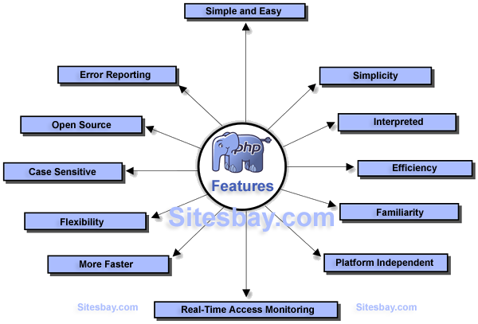
SOFTWARE REQUIREMENT ANALYSIS

1) Design Constraints and Dependencies:-

Here we can use the foreign key for showing the dependency and Primary key use to create a unique attribute which is non-repeatable key/attribute in the whole relationship which is uniquely identified.

2)Hardware & Software Requirement:-
Hardware Requirement:-
- Minimum 2 GB RAM.
- Minimum 2 GB HDD
- Processor P4 & Above
Software Requirement:-

- Windows XP and above
- Sublime Text Editor , Notepad++
- Xamp SQL Server
- Chrome

3) User Summary:-

Each Customer would be able to only view his/her Data about gas booking as well as full summary of Gas Booked in a year with respective Date and time. Customer would be able to view total Gas booked in a year where the details are calculated by system.

RISK MANAGEMENT

1) Risk Projection:-

Risk projection, also called risk estimation, attempts to rate each risk in two ways—
(1) The likelihood or probability that the risk is real and
(2) The consequences of the problems associated with the risk, should it occur. You work along with other managers and technical staff to perform four risk projection

Steps:
1. Establish a scale that reflects the perceived likelihood of a risk.
2. Delineate the consequences of the risk.
3. Estimate the impact of the risk on the project and the product.
4. Assess the overall accuracy of the risk projection so that there will be no
Misunderstandings.

2) Risk Identification (analysis):-

It is product of probability of the event occurring and the loss of the account of event. Following are some risk which will be occurred while working:

1. Due to power failure, the system will be corrupted.
2. Sometimes the data may be corrupted. At that times, there should any alternative.
3. Technical problems are also there.

3) Risk Monitoring & Mitigation:-

All of the risk analysis activities presented to this point have a single goal—to assist the project team in developing a strategy for dealing with risk. An effective strategy must consider three issues: risk avoidance, risk monitoring, and risk management and contingency planning.
If a software team adopts a proactive approach to risk, avoidance is always the
Best strategy. This is achieved by developing a plan for risk mitigation. For example, assume that high staff turnover is noted as a project risk r1. Based on past history and management intuition, the likelihood l1 of high turnover is estimated to be 0.70 (70 percent, rather high) and the impact x1 is projected as critical. That is, high turnover will have a critical impact on project cost and schedule.
To mitigate this risk, you would develop a strategy for reducing turnover. Among
The possible steps to be taken are:

• Meet with current staff to determine causes for turnover (e.g., poor working
Conditions, low pay, competitive job market).
• Mitigate those causes that are under your control before the project starts.
• Once the project commences, assume turnover will occur and develop techniques to ensure continuity when people leave.
• Organize project teams so that information about each development activities widely dispersed.

As the project proceeds, risk-monitoring 0.activities commence. The project manager monitors factors that may provide an indication of whether the risk is becoming more or less likely. In the case of high staff turnover, the general attitude of team
Members based on project pressures, the degree to which the team has jelled, interpersonal relationships among team members, potential problems with compensation and benefits, and the availability of jobs within the company and outside it are all monitored.

PROJECT MANAGEMENT

1) Project Plan:-

The objective of software project planning is to provide a framework that enables the manager to make reasonable estimates of resources, cost, and schedule. In addition , estimates should attempt to define best-case and worst-case scenarios so that project outcomes can be bounded. Although there is an inherent degree of uncertainty, the software team embarks on a plan that has been established as a consequence of these tasks. Therefore, the plan must be adapted and updated as the project proceeds.

2) Resources :-

1.Faculty.
2.Lab Assistant.
3.MSBTE website.

Project Goals

1) Goals of Project:-

The main goals of project is to Online booking of Gas by eliminating the manual work and saving Customer`s time and he can maintain the record of Customers in a well-documented manner as well as help the customer to view their details of gas booking and delivery report , time and date.

Diagrams

1) Use Case Diagram:-

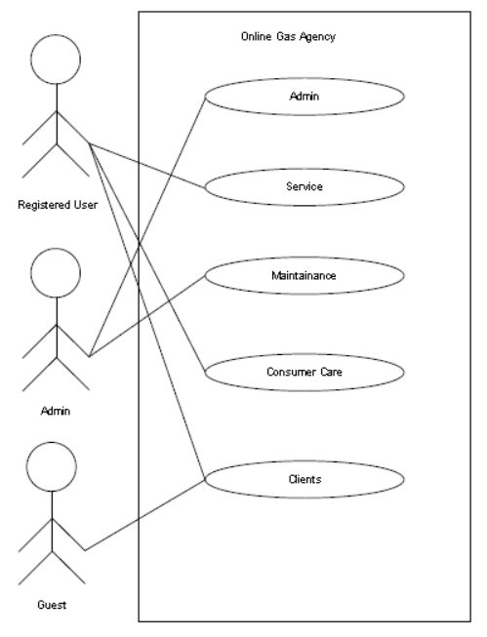

2) Class Diagram:-
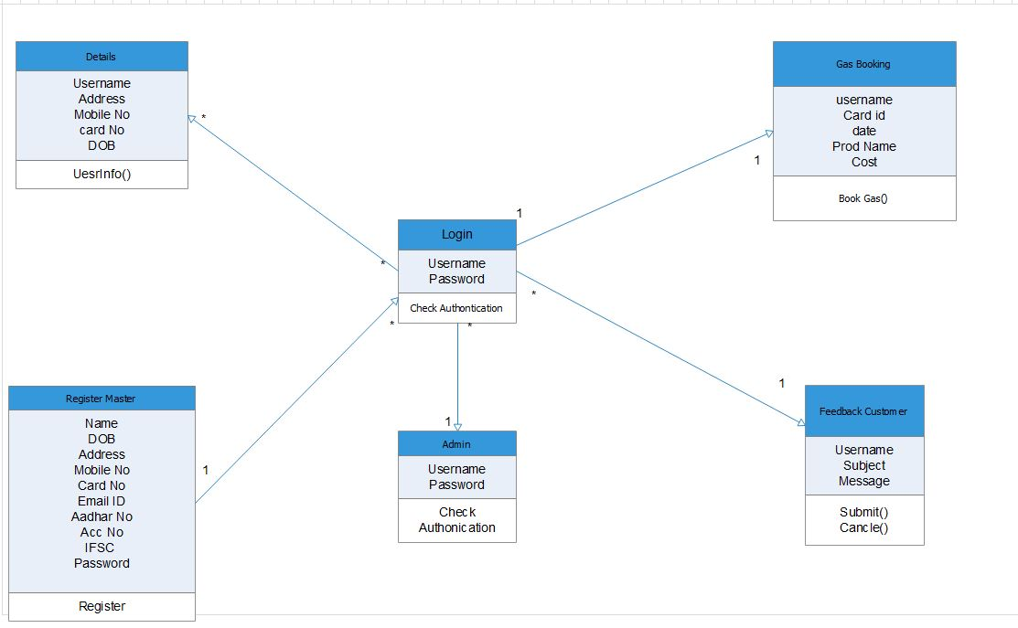

3)System Activity Diagram:
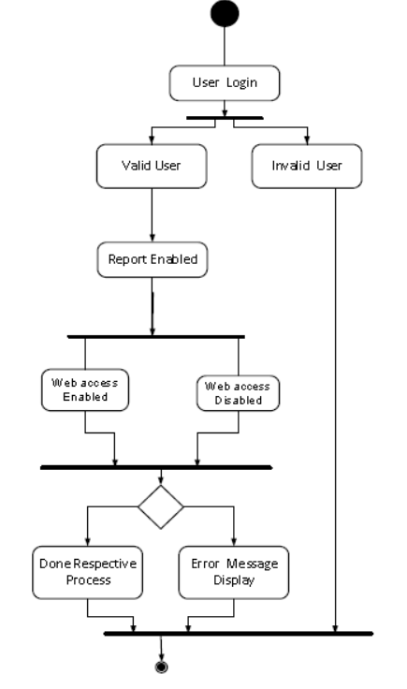

4)Data Flow Diagrams :-
Level 0:-
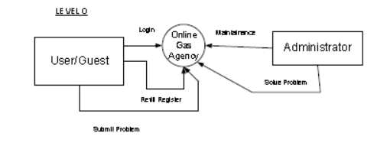

Level 1:-

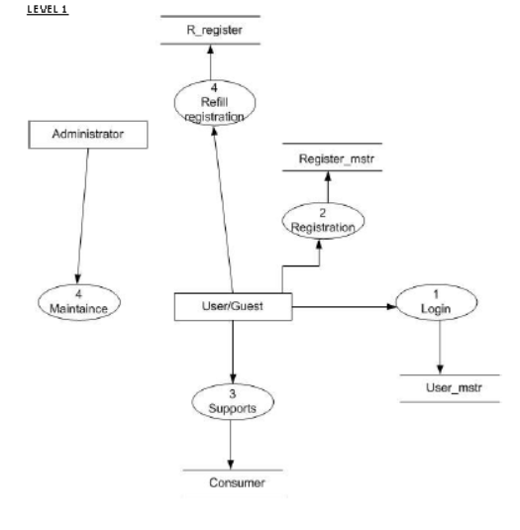

5)Control Flow Diagram:-

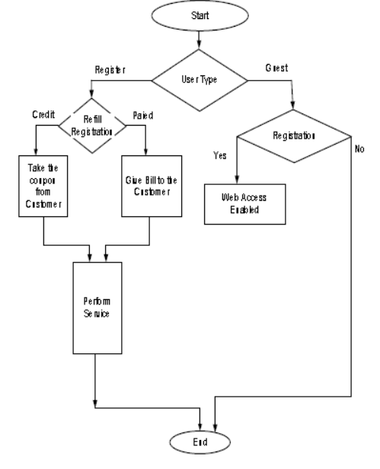

6)Sequence Diagram:-

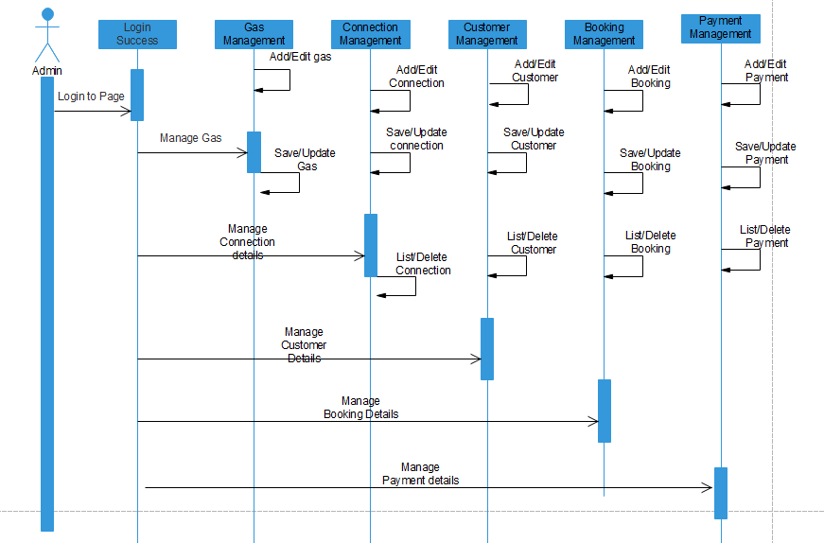

SYSTEM IMPLEMENTATION

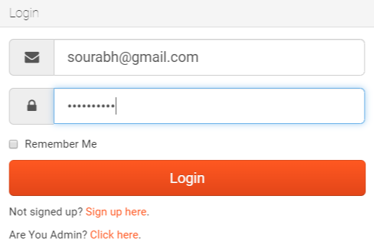

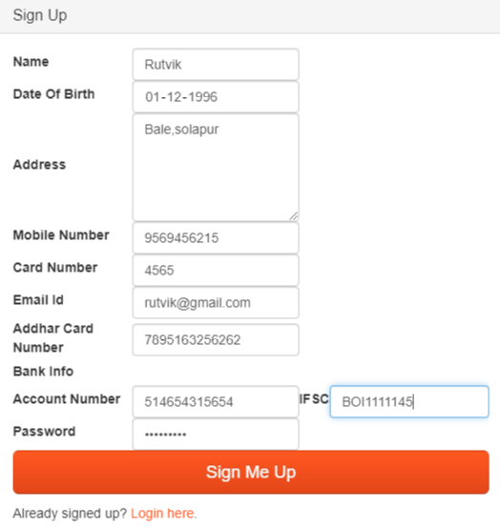

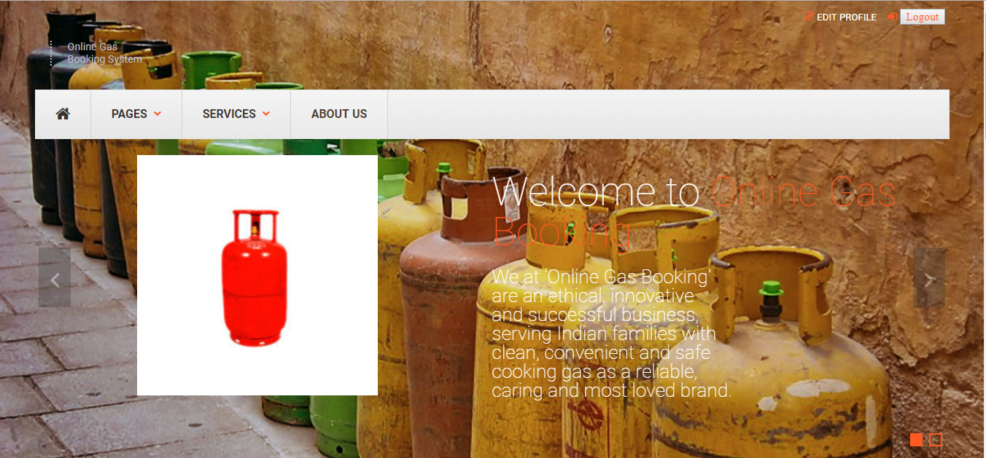

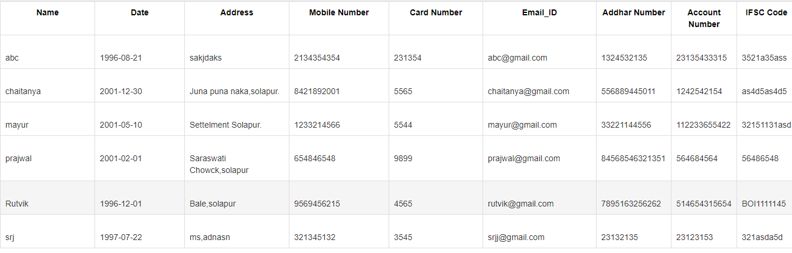

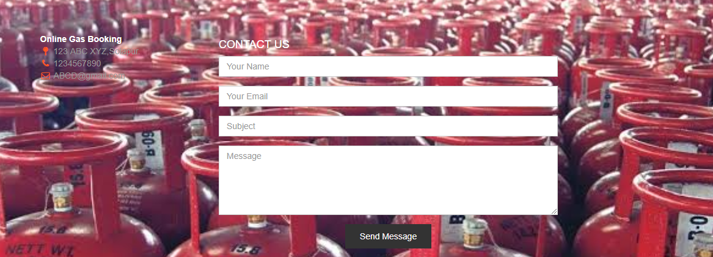

CODING
ADMIN LOGIN PAGE
<?php include("head1.php"); ?>
<?php include("server.php");?>
<?php include('errors.php')?>
<!--======== @Region: body ======== -->

<head>
<title>
Login
</title>
</head>
<body class="fullscreen-centered page-login">
<!--Change the background class to alter background image, options are: benches, boots, buildings, city, metro -->
<div id="background-wrapper" class="benches" data-stellar-background-ratio="0.8">

<!-- ======== @Region: #content ======== -->

<div id="content">
<div class="header">
<div class="header-inner">
<h1 align="center">Online Gas Booking</h1>
</div>
</div>
<div class="row">
<div class="col-sm-6 col-sm-offset-3">
<div class="panel panel-default">
<div class="panel-heading">
<h3 class="panel-title">
Login
</h3>
</div>
<div class="panel-body">
<form accept-charset="UTF-8" role="form" method="POST" action="server.php">
<fieldset>

<?php include('errors.php');?>

<div class="form-group">
<div class="input-group input-group-lg">
<span class="input-group-addon"><i class="fa fa-fw fa-envelope"></i></span>
<input type="text" class="form-control" placeholder="Email" name="email">
</div>
</div>
<div class="form-group">
<div class="input-group input-group-lg">
<span class="input-group-addon"><i class="fa fa-fw fa-lock"></i></span>
<input type="password" class="form-control" placeholder="Password" name="pass">
</div>
</div>
<div class="checkbox">
<label>
<input name="remember" type="checkbox" value="Remember Me">
Remember Me
</label>
</div>
<input class="btn btn-lg btn-primary btn-block" type="submit" value="Login" name="login2">
</fieldset>
</form>
<p class="m-b-0 m-t">Not signed up? <a href="admin_reg.php">Sign up here</a>.</p>
<p class="m-b-0 m-t">Are You User? <a href="index.php">Click Here</a>.</p>

</div>
</div>
</div>
</div>
<!-- /row -->
</div>
</div>

<?php include("foot1.php"); ?>

Login Page

<?php include("head1.php"); ?>
<?php include('errors.php')?>
<!--======== @Region: body ======== -->

<head>
<title>
Login
</title>
</head>
<body class="fullscreen-centered page-login">
<?php
require('db.php');
session_start();
//if form is submitted, insert values into the database.
if (isset($_POST['email'])){

$username = stripslashes($_REQUEST['email']); //removes backslashes
$email = mysqli_real_escape_string($con,$username); //escapes special characters in a string
$password1 = stripslashes($_REQUEST['password1']);
$password1 = mysqli_real_escape_string($con,$password1);

//checking is user existing in the database or not

$query="SELECT * FROM registration WHERE email='$email' AND password1='$password1'"; $result = mysqli_query($con,$query) or die(mysqli_error());
$rows = mysqli_num_rows($result);
if($rows==1){
$_SESSION['email'] = $email;
header("location: home.php"); //redirect user to billing.php
} else{
echo "<script>alert('Invalid Username or Password')</script>";
header('refresh: 0.1; url=index.php');
}
} else{
?>
<!--Change the background class to alter background image, options are: benches, boots, buildings, city, metro -->

<div id="background-wrapper" class="benches" data-stellar-background-ratio="0.8">

<!-- ======== @Region: #content ======== -->

<div id="content">
<div class="header">
<div class="header-inner">
<h1 align="center">Online Gas Booking</h1>
</div>
</div>
<div class="row">
<div class="col-sm-6 col-sm-offset-3">
<div class="panel panel-default">
<div class="panel-heading">
<h3 class="panel-title">
Login
</h3>
</div>
<div class="panel-body">
<form method="POST" action="" name="login">
<fieldset>

<?php include('errors.php');?>

<div class="form-group">
<div class="input-group input-group-lg">
<span class="input-group-addon"><i class="fa fa-fw fa-envelope"></i></span>
<input type="text" class="form-control" placeholder="Email" name="email" required>
</div>
</div>
<div class="form-group">
<div class="input-group input-group-lg">
<span class="input-group-addon"><i class="fa fa-fw fa-lock"></i></span>
<input type="password" class="form-control" placeholder="Password" name="pass" required>
</div>
</div>
<div class="checkbox">
<label>
<input name="remember" type="checkbox" value="Remember Me">
Remember Me
</label>
</div>
<input class="btn btn-lg btn-primary btn-block" type="submit" value="Login" name="login">
</fieldset>
</form>
<p class="m-b-0 m-t">Not signed up? <a href="register.php">Sign up here</a>.</p>

<p class="m-b-0 m-t">Are You Admin? <a href="admin_login.php">Click here</a>.</p>

</div>
</div>
</div>
</div>
<!-- /row -->
</div>
</div>
<?php } ?>
<?php include("foot1.php"); ?>
Home Page

<?php include("header.php"); ?>

<head>
<title>Home</title>
</head>

<!-- ======== @Region: #content ======== -->
<div id="content">
<!-- Mission Statement -->
<div class="mission text-center block block-pd-sm block-bg-noise">
<div class="container">
<h2 class="text-shadow-white">
Welcome <?php echo $b; ?> To Online Gas Booking
</h2>
</div>
</div>

<!--Services-->
<div class="showcase block block-border-bottom-grey">
<div class="container">
<h2 class="block-title">
Our Services
</h2>

<div class="item-carousel" data-toggle="owlcarousel" data-owlcarousel-settings='{"items":4, "pagination":false, "navigation":true, "itemsScaleUp":true}'>
<div class="item">
<a href="#" class="overlay-wrapper">
<img src="img/Services/Book Gas.jpg" alt="Project 1 image" class="img-responsive underlay">
<span class="overlay">
<span class="overlay-content"> <span class="h4">Book Gas</span> </span>
</span>
</a>
<div class="item-details bg-noise">
<h4 class="item-title">
<a href="Book Cylinder.php">Book Gas</a>
</h4>
<a href="#" class="btn btn-more"><i class="fa fa-plus"></i>Read more</a>
</div>
</div>
<div class="item">
<a href="#" class="overlay-wrapper">
<img src="img/Services/ns.png" alt="Project 2 image" class="img-responsive underlay">
<span class="overlay">
<span class="overlay-content"> <span class="h4">Nearest Service Center</span> </span>
</span>
</a>
<div class="item-details bg-noise">
<h4 class="item-title">
<a href="Nearest Service Center.php">Nearest Service Center</a>
</h4>
<a href="#" class="btn btn-more"><i class="fa fa-plus"></i>Read more</a>
</div>
</div>
<div class="item">
<a href="#" class="overlay-wrapper">
<img src="img/showcase/project5.png" alt="Project 5 image" class="img-responsive underlay">
<span class="overlay">
<span class="overlay-content"> <span class="h4">Edit Profile</span> </span>
</span>
</a>
<div class="item-details bg-noise">
<h4 class="item-title">
<a href="#">Edit Profile</a>
</h4>
<a href="#" class="btn btn-more"><i class="fa fa-plus"></i>Read more</a>
</div>
</div>
<div class="item">
<a href="#" class="overlay-wrapper">
<img src="img/showcase/project6.png" alt="Project 6 image" class="img-responsive underlay">
<span class="overlay">
<span class="overlay-content"> <span class="h4">About US</span> </span>
</span>
</a>
<div class="item-details bg-noise">
<h4 class="item-title">
<a href="about.php">About US</a>
</h4>
<a href="#" class="btn btn-more"><i class="fa fa-plus"></i>Read more</a>
</div>
</div>
<div class="item">
<a href="#" class="overlay-wrapper">
<img src="img/showcase/project7.png" alt="Project 7 image" class="img-responsive underlay">
<span class="overlay">
<span class="overlay-content"> <span class="h4">Freaquently Asked Questions</span> </span>
</span>
</a>
<div class="item-details bg-noise">
<h4 class="item-title">
<a href="FAQ.php">FAQ</a>
</h4>
<a href="#" class="btn btn-more"><i class="fa fa-plus"></i>Read more</a>
</div>
</div>
<div class="item">
<a href="sefty tips.html" class="overlay-wrapper">
<img src="img/showcase/project8.png" alt="Project 8 image" class="img-responsive underlay">
<span class="overlay">
<span class="overlay-content"> <span class="h4">Sefty Tips</span> </span>
</span>
</a>
<div class="item-details bg-noise">
<h4 class="item-title">
<a href="sefty tips.html">Sefty Tips</a>
</h4>
<a href="#" class="btn btn-more"><i class="fa fa-plus"></i>Read more</a>
</div>
</div>
</div>
</div>
</div>
<!--/Services -->

<!--Customer testimonial-->
<div class="testimonials block-contained">
<div class="row">
<!--Customer testimonial-->
<div class="col-md-6 m-b-lg">
<h3 class="block-title">
Testimonials
</h3>
<blockquote>
<p>Our productivity &amp; sales are up! Customers are happy &amp; we couldn't be happier with this product!</p>
<img src="img/misc/charles-quote.png" alt="Charles Spencer Chaplin">
<small>
<strong>Charles Chaplin</strong>
<br>
British comic actor
</small>
</blockquote>
</div>
</div>
</div>
<!--Customer testimonial-->

<?php include ("footer.php"); ?>

TESTING

Testing is the process carried out on software to detect the differences between
its behavior and the desired behavior as stipulated by the requirements specifications.
Testing is advantageous in several ways. Firstly, the defects found help in the
process of making the software reliable. Secondly, even if the defects found are not
corrected, testing gives an idea as to how reliable the software is. Thirdly, over time, the
record of defects found reveals the most common kinds of defects, which can be used for
developing appropriate preventive measures such as training, proper design and
reviewing.

- TEST PLAN:-

The testing sub-process includes the following activities in a phase dependent manner:
a) Create Test Plans.
b) Create Test Specifications.
c) Review Test Plans and Test Specifications.
d) Conduct tests according to the Test Specifications, and log the defects.
e) Fix defects, if any.
f) When defects are fixed continue from activity.
- TESTING STRATEGY:-
The purpose of test management is to ensure that a testing strategy is both
devised and applied that is efficient, effective and economic. The testing strategy should
define the objectives of all test stages and the techniques that apply. The testing strategy
also forms the basis for the creation of a standardized documentation set, and facilitates
communication of the test process and its implications outside of the test discipline. Any
test support tools introduced should be aligned with, and in support of, the test strategy.

3) TESTING METHODS;-

Out of the above discussed testing methods, we adopted the Integration Testing
and Unit Testing strategies. We divided all the main module of our project in the
manageable units, prepared them individually and then tested them as per their working
strategy. After the individual testing of each such module, we integrated them module
wise and tested the whole modules individually. When we were satisfied with the
working of each individual module, we tested them for the compatibleness of each
module with the other one. Hence we travelled from the smallest manageable units to
the whole project testing.

Conclusion

The design of the website is done by taking into consideration all the
needs of the agency. The intention of this whole system is to computerize the entire
existing system and solve all Problems of the Existing System. This system is useful for all
gas agencies. This system will is designed to save time and will reduce the complexity and is also user friendly.
1) Future Scope:-

The developed system can be used in any Gas Agency for the Online Gas Booking system for customizing the old system.

APPENDIX

1) Tools & Software:
- Windows XP and above
- Subline Text Editor,Notepad++
- Xamp SQL Server
- Chrome

2) Websites:
www.Google.Com
www.w3schools.Com
www.awwards.Com
www.wikipedia.Com

3) Books:
1. PHP - The Complete References.
2. Programming PHP.
3. Dynamic SQL.
4.HTML5 BLACK

